**Journey of C++**

Halloo friends!!!!!....First of all we need a platform for run or develop

project using c++.So we need a Platform called visual studio 2022 .

So, Let’s see About How to download visual studio??

**Step 1:** Go to google and type visual studio download…..Then click first link..:)

**Step 2:** Then you see three options like Community, Professional and Enterprise.

For our use we click in community Edition that is for free download.

Professional and Enterprise are paid and used in Startups and large oganisation.

**Step 3:** And we got a executable file..…

**Step 4:** Then click it and Install….:)

**Step 5:** Then, we want to setup vs code 2022…..

so go to vs installer and click “Modify”.

**Step 6:** And select the components and packages to do projects using c++.

Then click”Install while download” and Apply.

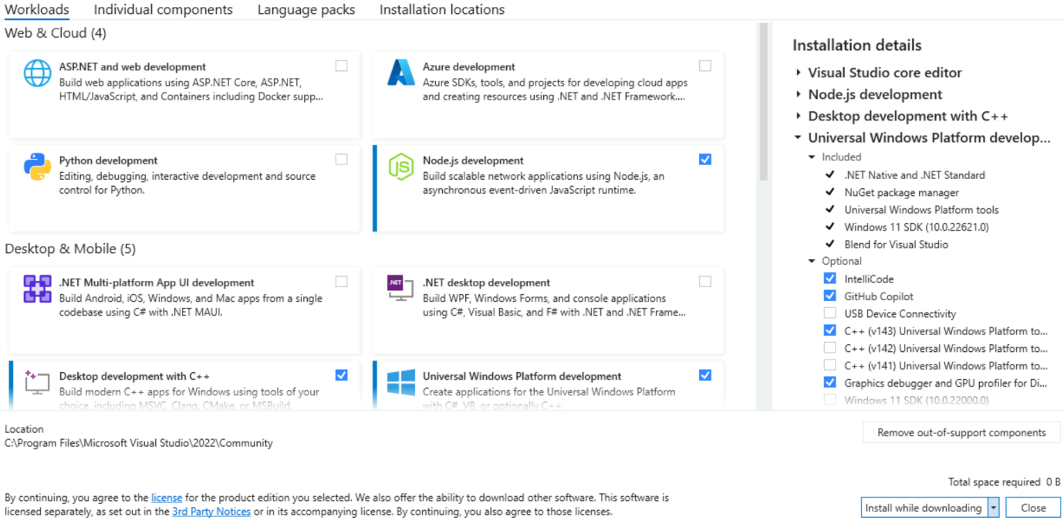

**Step 7:** After Installing , click…”Launch”.

**Step 8:** After Launch create new project.

**Step 9:** In search bar search “C++”. And select Empty Project.

**Step 10:** Next we want to give one project name as our wish…Then Click “Create”

**Step 11:** Then enter the platform for coding….here in solution explorer…click “Show All Files” to hide some files.

**Step 12:** Then Right Click and create a new folder.

Like inc,src files…

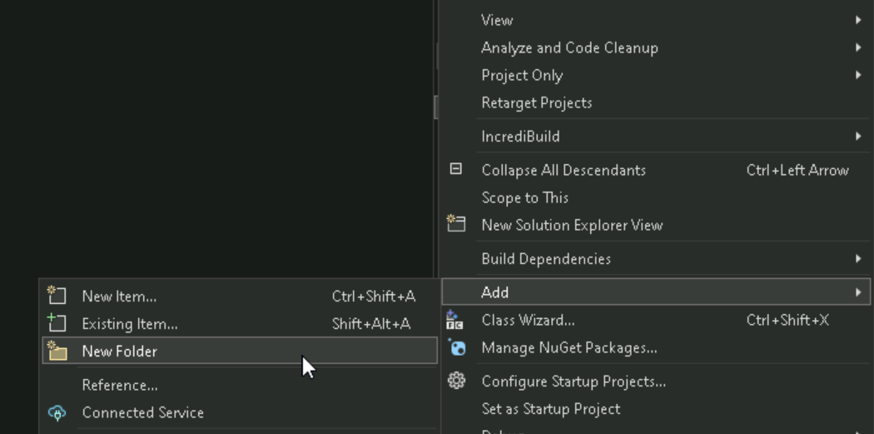

**Step 13:** Then create a new program file in src like “Hell.cpp” .

**Step 14:** Then click that spanner i.e, Properties. For Adding bin file.

**Step 15:** Then click between solution and platform and add “bin\”

Then click Apply and Ok.

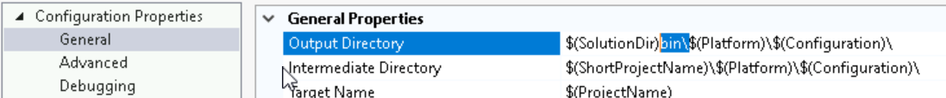

**Step 16:** Then we want to build and refresh in Solution Explorer then the bin file is Created….:)

**Step 17:** Next we write code in in “Hell.cpp” .

**Step 18:** Then, Build this program..

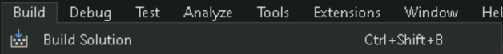

**Step 19:** Then, Run This program using the run button.



**Step 20: Then, console pop up and Output of the program as “Hello World”.**

**Step 21:** Then, if you want to create a header file click inc folder and create new header file like “new.h”

**Step 22:** Then, Declare a function as,

**Step 23:** Then, create one more cpp file as “trex.cpp” for function definition.

**Step 24:** Then, Define a function For example ,multiply

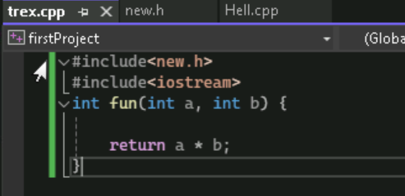

**Step 25:** Then, include the inc file i.e, new.h and Apply then OK.

**Step 26:** Then build, And Run the program using run Button.

